AMBIKA KASHYAP

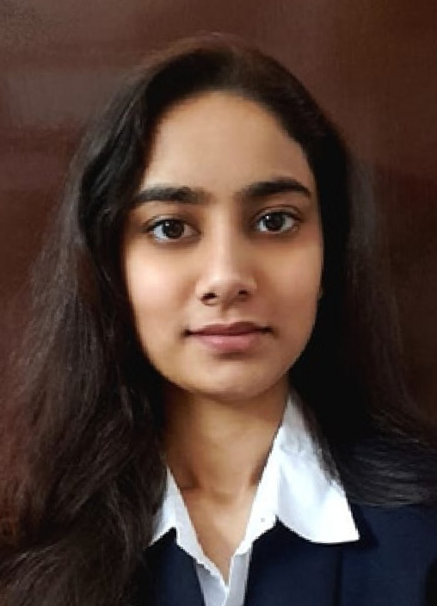

[**MY CONTACT**](https://www.linkedin.com/in/ambika70026)

[+91 7814065959](https://www.linkedin.com/in/ambika70026)

[ambikakashyap736@gmail.com https://www.linkedin.com/in/ambika 70026](https://www.linkedin.com/in/ambika70026)

[Mohali,Punjab](https://www.linkedin.com/in/ambika70026)

**Github**: https://github.com/AMBIKAKAS

[**TECHNICAL SKILLS**](https://www.linkedin.com/in/ambika70026)

[HTML|CSS|JAVASCRIPT|NODE.JS| SQL|PYTHON|C++](https://www.linkedin.com/in/ambika70026)

[**SOFT SKILLS**](https://www.linkedin.com/in/ambika70026)

[Problem-Solving • Idea Generation • Communication Skills • Time Management](https://www.linkedin.com/in/ambika70026)

[**ACHIEVEMENTS**](https://www.linkedin.com/in/ambika70026)

(VERIFIED CREDENTIALS ON LINKDEN)

[Postman API Fundamental Student expert|Postman|Issued:Aug 2024 SQL(intermediate)certificate|Hackerank| Issued:Aug,2024](https://www.linkedin.com/in/ambika70026)

[Devpost hosted Hackathon Winner Community Impact Award,November2024](https://www.linkedin.com/in/ambika70026)

Microsoft Certified: Azure Fundamentals

Issued on:July,2025

[**HOBBIES**](https://www.linkedin.com/in/ambika70026)

[Baking](https://www.linkedin.com/in/ambika70026)

[Experimenting UI Designs](https://www.linkedin.com/in/ambika70026)

# CAREER OBJECTIVE

As a Computer Science student specializing in Cloud Computing, I aim to work in the development domain to create **innovative, efficient, and scalable applications**. I am passionate about leveraging technologies to solve real-world problems and eager to contribute to **impactful projects** that provide **user-centric software solutions.**

# EDUCATION

**Pursuing B.E. in Computer Science (Hons.) – Cloud Computing with IBM**|Chandigarh University, Gharuan, Punjab

## Expected Graduation: June 2027 First Year CGPA: 8.66/10

## Second Year CGPA:8.72/10

**Higher Secondary**|Sri Guru Gobind Singh Senior Secondary School, Sector 35 A,Chandigarh

## Percentage:80.2% Year-(2021-2023)

**Secondary Education**|Carmel Convent, Sector 9B, Chandigarh

Aggregate: 93.4% Year-(2009-2020)

# PROJECTS

Farm Flood Aid -[Hackathon Winner](https://buildmyanmar.org/hackathon/?utm_source=chatgpt.com)

https://flood-management-website.vercel.ap p/ Timeline: November 2024

Problem: Flood-affected farmers lack crop protection and support. Solution: **AI chatbot, surplus crop marketplace, NGO directory.**

Tech Stack: HTML, CSS, JS, EJS, Node.js, Express, MongoDB Role: **Front-End, Idea Generation**

FinLink -[website](https://github.com/itsnikhil24/Finlink)

Timeline: Janaury 2025

Problem: Limited access to financial experts and lack of collaborative platforms for skill-sharing.

Solution: Web app enabling expert consultations, real-time chats, a barter-based skill-sharing system, and user growth tracking.

Tech Stack: HTML, CSS, JS, EJS, Node.js, Express, MongoDB Role: **Front-End, Idea Generation**